Cryptography
Cryptography is one of the subjects in computer science that focus on secure communication between the sender and receiver and also discusses the methods we can use to secure digital data like digital signature uploaded on the internet.
With cryptography, we do not need to worry about the confidentiality and integrity of the data during transmission.

You need to know a few terms we will frequently use during the explanation.
- Plaintext: The standard text we will convert into a non-readable format.
- Ciphertext: The text we will generate after converting the plain text by applying cryptography techniques.
- Key: A key is a string of characters or bits that helps us convert plain text into cipher text and is only known to the sender and receiver.
- Encryption: Encryption converts plain text into cipher text with the help of a secret key.
- Decryption: Decryption converts cipher text into standard or plain text with the help of a secret key.

Cryptanalysis

Cryptanalysis is the field of cryptology to study and observes encryption and decryption methods or techniques. In cryptanalysis, the person analyses the encryption methods by testing them with different scenarios providing a more secure solution and fixing any vulnerabilities or loopholes. The person who studies the field of cryptanalysis is known as a cryptanalyst. A cryptanalyst will try to decode the ciphertext with as little information as possible.
In comparison, cryptography focuses on creating the algorithm to provide encryption and decryption of the data. Cryptanalysis studies those algorithms and tries to find a flaw in these algorithms. After reviewing the cryptography algorithms, the cryptanalyst provides a report to improve these algorithms.

Use of Cryptanalysis
- Various organizations and companies rely on cryptanalysis to secure their confidential information or data or to maintain secure communication.
- Cryptanalysis is essential for cryptology to implement ciphers that do not leak sensitive information to a potential threat.
- Cryptography provides secure algorithms to encrypt data. Cryptanalysis tries to find flaws in the algorithm by studying its design and workings.
Let's try to understand the working of cryptanalysis through a real-life example.
Assume there are two persons in an organization communicating on a secure network.

As you can see in the picture, a cryptanalyst or potential attacker is eavesdropping on a network and have access to the cipher text sent from person1 to person2. This is called a man-in-the-middle attack.
The cryptanalyst has the information of the Cipher text, and he will analyze the given cipher text and try to decrypt the message or find the key to decrypt the message. If he can accomplish it, the organization's encryption algorithm could be more secure.

Attacks in Cryptanalysis

As mentioned above, you must know the encryption method or information related to this encryption method, like ciphertext or plaintext, to implement cryptanalysis.
Based on this information, the cryptanalyst can use various attacks or techniques.
Known Ciphertext Attack
- Ciphertext-only attacks, or known ciphertext attack, is the most commonly used attack by a cryptanalyst.
- In most scenarios, the cryptanalyst has access to the ciphertext or some of the encrypted messages.
- The cryptanalyst needs to learn the rest of the information, like the encryption algorithm or secret key.
- The cryptanalyst has to analyze the encryption process using the ciphertext only. The ciphertext has to be checked or reviewed to determine whether it is not leaking any information to the attacker because ciphertext is primarily accessible by an individual.
Known Plaintext Attack
- In the known plaintext attack, the cryptanalyst has access to the ciphertext and some parts of the plaintext. In known plaintext attacks, the cryptanalyst's primary motive is to find the secret key or encryption algorithm.
- For example, let's assume you got to know about the plaintext and ciphertext sent over a network. Now, as a cryptanalyst, you need to determine whether the plaintext and ciphertext are leaking any information about the secret key and encryption algorithm because the organization may use that private key and encryption algorithm frequently.
- It is not an issue in modern-day cryptography because modern-day encryption algorithms are plaintext attack resistant. The known-plaintext attack was primarily active during wars to analyze the old encryption techniques.
Chosen Plaintext Attack.
- In a chosen-plaintext attack, the attacker can select an arbitrary plaintext and encrypt that plaintext.
- The chosen plaintext attack is mainly used when an attacker has access to an encryption device. Then the attacker or cryptanalyst can choose a plaintext and get the corresponding ciphertext.
- The motive is to perform the encryption many times with different plaintext with some similarity and analyze the results to obtain essential information.
- In chosen plaintext attack, the cryptanalyst observes similar patterns received during plaintext encryption.
Chosen Ciphertext Attack
- The working of chosen ciphertext attack is the same as chosen plaintext attack, but in this attack, the attacker chooses a ciphertext and sees its corresponding plaintext.
- It is applied to the decryption function of the cryptography system.
Man-in-the-middle Attack
- In a Man-in-the-middle attack, the attacker will intercept communication between two parties.
- He will be eavesdropping on the channel and will try to find some information or data during the communication.
- He can encrypt or decrypt the message assuming he has access to the secret key.
- He can also alter the text or message for the receiver.
- An organization must build a robust and authentic communication or transaction channel to avoid such attacks.

Responsibilities of Cryptanalyst
Cryptanalyst work ethically means any analysis they do will only be for the betterment of the algorithm and to prevent any hacker's attack on a system. There are a few responsibilities that you should know of a cryptanalyst.
- To Prevent theft, copying, modification, or deletion of sensitive data.
- To Identify, evaluate, and focus on the cryptographic security system and algorithm flaws.
- To Design security solutions to guard against weaknesses.
- To Construct statistical and mathematical models to assess data and address security issues.
- To Test the precision and dependability of computational models.
- Investigating, exploring, and testing new applications and theories of cryptology.

Frequently Asked Questions

Who is a cryptanalyst?
The person who studies cryptanalysis is known as the cryptanalyst.

What is the role of a cryptanalyst?
The part of a cryptanalyst is to analyze cryptography algorithms and find their vulnerabilities in them.

Does cryptanalysis is an illegal process?
No, it is government recognized process implemented by ethical professionals.

What is a ciphertext-only attack?
The attacker in a ciphertext-only attack only has access to one or more encrypted messages.

Conclusion
In this blog, we discussed the analysis in cryptography or cryptanalysis. We discussed the differences between cryptography and cryptanalysis. We also demonstrated an example of process cryptanalysis. We have also discussed various attacks a cryptanalyst uses and the responsibilities of a cryptanalyst.

Caesar cipher
The Caesar cipher is a classic example of ancient cryptography and is said to have been used by Julius Caesar. The Caesar cipher is based on transposition and involves shifting each letter of the plaintext message by a certain number of letters, historically three, as shown in Figure 5.1. The ciphertext can be decrypted by applying the same number of shifts in the opposite direction. This type of encryption is known as a substitution cipher, due to the substitution of one letter for another in a consistent fashion.
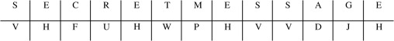
Sign in to download full-size image
Figure 5.1. Caesar cipher.
A more recent variation of the Caesar cipher can be found in the ROT13 cipher. ROT13 uses the same mechanism as the Caesar cipher but moves each letter 13 places forward. The convenience of moving 13 places lies in the fact that applying another round of encryption with ROT13 also functions as decryption, as two rotations will return us to the original starting place in the alphabet. Utilities for performing ROT13 can be found in the basic set of tools that ship with many Linux and UNIX operating systems. There are a number of simple systems that are built around simple transposition.

1. Monoalphabetic Cipher :
A monoalphabetic cipher is any cipher in which the letters of the plain text are mapped to cipher text letters based on a single alphabetic key. Examples of monoalphabetic ciphers would include the Caesar-shift cipher, where each letter is shifted based on a numeric key, and the atbash cipher, where each letter is mapped to the letter symmetric to it about the center of the alphabet.
2. Polyalphabetic Cipher :
A polyalphabetic cipher is any cipher based on substitution, using multiple substitution alphabets. The Vigenère cipher is probably the best-known example of a polyalphabetic cipher, though it is a simplified special case.
Difference Between Monoalphabetic Cipher and Polyalphabetic Cipher :

SR.NO | Monoalphabetic Cipher | Polyalphabetic Cipher
1 | Monoalphabetic cipher is one where each symbol in plain text is mapped to a fixed symbol in cipher text. | Polyalphabetic cipher is any cipher based on substitution, using multiple substitution alphabets.
2 | The relationship between a character in the plain text and the characters in the cipher text is one-to-one. | The relationship between a character in the plain text and the characters in the cipher text is one-to-many.
3 | Each alphabetic character of plain text is mapped onto a unique alphabetic character of a cipher text. | Each alphabetic character of plain text can be mapped onto ‘m’ alphabetic characters of a cipher text.
4 | A stream cipher is a monoalphabetic cipher if the value of key does not depend on the position of the plain text character in the plain text stream. | A stream cipher is a polyalphabetic cipher if the value of key does depend on the position of the plain text character in the plain text stream.
5 | It includes additive, multiplicative, affine and monoalphabetic substitution cipher. | It includes autokey, Playfair, Vigenere, Hill, one-time pad, rotor, and Enigma cipher.
6 | It is a simple substitution cipher. | It is multiple substitutions cipher.
7 | Monoalphabetic Cipher is described as a substitution cipher in which the same fixed mappings from plain text to cipher letters across the entire text are used. | Polyalphabetic Cipher is described as substitution cipher in which plain text letters in different positions are enciphered using different cryptoalphabets.
8 | Monoalphabetic ciphers are not that strong as compared to polyalphabetic cipher. | Polyalphabetic ciphers are much stronger.

Columnar Transposition Cipher

Given a plain-text message and a numeric key, cipher/de-cipher the given text using Columnar Transposition Cipher
The Columnar Transposition Cipher is a form of transposition cipher just like Rail Fence Cipher. Columnar Transposition involves writing the plaintext out in rows, and then reading the ciphertext off in columns one by one.
Examples:
Encryption
Input : Geeks for Geeks
Key = HACK
Output : e kefGsGsrekoe_
Decryption
Input : e kefGsGsrekoe_
Key = HACK
Output : Geeks for Geeks

Encryption
Input : Geeks on work
Key = HACK
Output : e w_eoo_Gs kknr_
Decryption
Input : e w_eoo_Gs kknr_
Key = HACK
Output : Geeks on work
Encryption
In a transposition cipher, the order of the alphabets is re-arranged to obtain the cipher-text.
- The message is written out in rows of a fixed length, and then read out again column by column, and the columns are chosen in some scrambled order.
- Width of the rows and the permutation of the columns are usually defined by a keyword.
- For example, the word HACK is of length 4 (so the rows are of length 4), and the permutation is defined by the alphabetical order of the letters in the keyword. In this case, the order would be “3 1 2 4”.
- Any spare spaces are filled with nulls or left blank or placed by a character (Example: _).
- Finally, the message is read off in columns, in the order specified by the keyword.
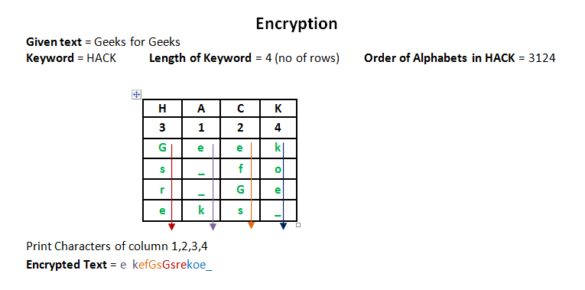
Decryption
- To decipher it, the recipient has to work out the column lengths by dividing the message length by the key length.
- Then, write the message out in columns again, then re-order the columns by reforming the key word.
  - C++
  - Python3
// CPP program for illustrating
// Columnar Transposition Cipher
#include<bits/stdc++.h>
using namespace std;

// Key for Columnar Transposition
string const key = "HACK";
map<int,int> keyMap;

void setPermutationOrder()
{
// Add the permutation order into map
for(int i=0; i < key.length(); i++)
{
keyMap[key[i]] = i;
}
}

// Encryption
string encryptMessage(string msg)
{
int row,col,j;
string cipher = "";

/* calculate column of the matrix*/
col = key.length();

/* calculate Maximum row of the matrix*/
row = msg.length()/col;

if (msg.length() % col)
row += 1;

char matrix[row][col];

for (int i=0,k=0; i < row; i++)
{
for (int j=0; j<col; )
{
if(msg[k] == '\0')
{
/* Adding the padding character '_' */
matrix[i][j] = '_';
j++;
}

if( isalpha(msg[k]) || msg[k]==' ')
{
/* Adding only space and alphabet into matrix*/
matrix[i][j] = msg[k];
j++;
}
k++;
}
}

for (map<int,int>::iterator ii = keyMap.begin(); ii!=keyMap.end(); ++ii)
{
j=ii->second;

// getting cipher text from matrix column wise using permuted key
for (int i=0; i<row; i++)
{
if( isalpha(matrix[i][j]) || matrix[i][j]==' ' || matrix[i][j]=='_')
cipher += matrix[i][j];
}
}

return cipher;
}

// Decryption
string decryptMessage(string cipher)
{
/* calculate row and column for cipher Matrix */
int col = key.length();

int row = cipher.length()/col;
char cipherMat[row][col];

/* add character into matrix column wise */
for (int j=0,k=0; j<col; j++)
for (int i=0; i<row; i++)
cipherMat[i][j] = cipher[k++];

/* update the order of key for decryption */
int index = 0;
for( map<int,int>::iterator ii=keyMap.begin(); ii!=keyMap.end(); ++ii)
ii->second = index++;

/* Arrange the matrix column wise according
to permutation order by adding into new matrix */
char decCipher[row][col];
map<int,int>::iterator ii=keyMap.begin();
int k = 0;
for (int l=0,j; key[l]!='\0'; k++)
{
j = keyMap[key[l++]];
for (int i=0; i<row; i++)
{
decCipher[i][k]=cipherMat[i][j];
}
}

/* getting Message using matrix */
string msg = "";
for (int i=0; i<row; i++)
{
for(int j=0; j<col; j++)
{
if(decCipher[i][j] != '_')
msg += decCipher[i][j];
}
}
return msg;
}

// Driver Program
int main(void)
{
/* message */
string msg = "Geeks for Geeks";

setPermutationOrder();

// Calling encryption function
string cipher = encryptMessage(msg);
cout << "Encrypted Message: " << cipher << endl;

// Calling Decryption function
cout << "Decrypted Message: " << decryptMessage(cipher) << endl;

return 0;
}
Output:
Encrypted Message: e kefGsGsrekoe_
Decrypted Message: Geeks for Geeks
Try it yourself: A double columnar transposition( It was used by the U.S. Army in World War I, and it is just a columnar transposition followed by another columnar transposition).
This article is contributed by Yasin Zafar. If you like GeeksforGeeks and would like to contribute, you can also write an article using write.geeksforgeeks.org or mail your article to review-team@geeksforgeeks.org. See your article appearing on the GeeksforGeeks main page and help other Geeks.
Please write comments if you find anything incorrect, or you want to share more information about the topic discussed above.

Rail Fence Cipher – Encryption and Decryption

A
Ashutosh_Kumar

• Read
• Discuss
• Courses
• Practice

Given a plain-text message and a numeric key, cipher/de-cipher the given text using Rail Fence algorithm.
The rail fence cipher (also called a zigzag cipher) is a form of transposition cipher. It derives its name from the way in which it is encoded.
Examples:
Encryption
Input : "GeeksforGeeks "
Key = 3
Output : GsGsekfrek eoe
Decryption
Input : GsGsekfrek eoe
Key = 3
Output : "GeeksforGeeks "

Encryption
Input : "defend the east wall"
Key = 3
Output : dnhaweedtees alf tl
Decryption
Input : dnhaweedtees alf tl
Key = 3
Output : defend the east wall

Encryption
Input : "attack at once"
Key = 2
Output : atc toctaka ne
Decryption
Input : "atc toctaka ne"
Key = 2
Output : attack at once

Encryption
In a transposition cipher, the order of the alphabets is re-arranged to obtain the cipher-text.
- In the rail fence cipher, the plain-text is written downwards and diagonally on successive rails of an imaginary fence.
- When we reach the bottom rail, we traverse upwards moving diagonally, after reaching the top rail, the direction is changed again. Thus the alphabets of the message are written in a zig-zag manner.
- After each alphabet has been written, the individual rows are combined to obtain the cipher-text.
For example, if the message is “GeeksforGeeks” and the number of rails = 3 then cipher is prepared as:
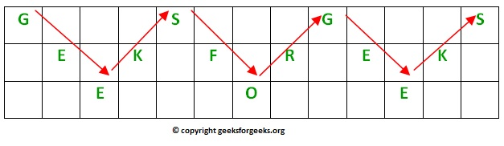
.’.Its encryption will be done row wise i.e. GSGSEKFREKEOE

Decryption
As we’ve seen earlier, the number of columns in rail fence cipher remains equal to the length of plain-text message. And the key corresponds to the number of rails.
- Hence, rail matrix can be constructed accordingly. Once we’ve got the matrix we can figure-out the spots where texts should be placed (using the same way of moving diagonally up and down alternatively ).
- Then, we fill the cipher-text row wise. After filling it, we traverse the matrix in zig-zag manner to obtain the original text.
Implementation:
Let cipher-text = “GsGsekfrek eoe” , and Key = 3
- Number of columns in matrix = len(cipher-text) = 13
- Number of rows = key = 3
Hence original matrix will be of 3*13 , now marking places with text as ‘*’ we get
* _ _ _ * _ _ _ * _ _ _ *
_ * _ * _ * _ * _ * _ *
_ _ * _ _ _ * _ _ _ * _
Below is a program to encrypt/decrypt the message using the above algorithm.
- C++
- Java
- Python3
- C#
- Javascript
// C++ program to illustrate Rail Fence Cipher
// Encryption and Decryption
#include <bits/stdc++.h>
using namespace std;

// function to encrypt a message
string encryptRailFence(string text, int key)
{
// create the matrix to cipher plain text
// key = rows , length(text) = columns
char rail[key][(text.length())];

// filling the rail matrix to distinguish filled
// spaces from blank ones
for (int i=0; i < key; i++)
for (int j = 0; j < text.length(); j++)
rail[i][j] = '\n';

// to find the direction
bool dir_down = false;
int row = 0, col = 0;

for (int i=0; i < text.length(); i++)
{
// check the direction of flow
// reverse the direction if we've just
// filled the top or bottom rail
if (row == 0 || row == key-1)
dir_down = !dir_down;

// fill the corresponding alphabet
rail[row][col++] = text[i];

// find the next row using direction flag
dir_down?row++ : row--;
}

//now we can construct the cipher using the rail matrix
string result;
for (int i=0; i < key; i++)
for (int j=0; j < text.length(); j++)
if (rail[i][j]!='\n')
result.push_back(rail[i][j]);

return result;
}

// This function receives cipher-text and key
// and returns the original text after decryption
string decryptRailFence(string cipher, int key)
{
// create the matrix to cipher plain text
// key = rows , length(text) = columns
char rail[key][cipher.length()];

// filling the rail matrix to distinguish filled
// spaces from blank ones
for (int i=0; i < key; i++)
for (int j=0; j < cipher.length(); j++)
rail[i][j] = '\n';

// to find the direction
bool dir_down;

int row = 0, col = 0;

// mark the places with '*'
for (int i=0; i < cipher.length(); i++)
{
// check the direction of flow
if (row == 0)
dir_down = true;
if (row == key-1)
dir_down = false;

// place the marker
rail[row][col++] = '*';

// find the next row using direction flag
dir_down?row++ : row--;
}

// now we can construct the fill the rail matrix
int index = 0;
for (int i=0; i<key; i++)
for (int j=0; j<cipher.length(); j++)
if (rail[i][j] == '*' && index<cipher.length())
rail[i][j] = cipher[index++];

// now read the matrix in zig-zag manner to construct
// the resultant text
string result;

row = 0, col = 0;
for (int i=0; i< cipher.length(); i++)
{
// check the direction of flow
if (row == 0)
dir_down = true;
if (row == key-1)
dir_down = false;

// place the marker
if (rail[row][col] != '*')
result.push_back(rail[row][col++]);

// find the next row using direction flag
dir_down?row++: row--;
}
return result;
}

//driver program to check the above functions
int main()
{
cout << encryptRailFence("attack at once", 2) << endl;
cout << encryptRailFence("GeeksforGeeks ", 3) << endl;
cout << encryptRailFence("defend the east wall", 3) << endl;

//Now decryption of the same cipher-text
cout << decryptRailFence("GsGsekfrek eoe",3) << endl;
cout << decryptRailFence("atc toctaka ne",2) << endl;
cout << decryptRailFence("dnhaweedtees alf tl",3) << endl;

return 0;
}
Output:
atc toctaka ne
GsGsekfrek eoe
dnhaweedtees alf tl
GeeksforGeeks
attack at once
defend the east wall
Time Complexity: O(row * col)
Auxiliary Space: O(row * col)
References:
https://en.wikipedia.org/wiki/Rail_fence_cipher
This article is contributed by Ashutosh Kumar If you like GeeksforGeeks and would like to contribute, you can also write an article using write.geeksforgeeks.org or mail your article to review-team@geeksforgeeks.org. See your article appearing on the GeeksforGeeks main page and help other Geeks.
Please write comments if you find anything incorrect, or you want to share more information about the topic discussed above.

. Steganography: Steganography is a method in which secret message is hidden in a cover media. Steganography means covered writing. Steganography is the idea to prevent secret information by creating the suspicion. Steganography is less popular than Cryptography. In steganography, structure of data is not usually altered. The forms of steganography are:
1. Text
2. Audio
3. Video
4. Images
5. Network or Protocol

2. Cryptography: Cryptography means secret writing. In cryptography, sender does not send message directly to the receiver, before sending information to the receiver information or plain text is converted into cipher text by using some encryption algorithm then send to the receiver and receiver decrypt the cipher text into plain text to read the original information. It is of two types:
1. Symmetric key cryptography
2. Asymmetric key cryptography
The difference between Steganography and Cryptography:
S.NO | Steganography | Cryptography
1. | Steganography means covered writing. | Cryptography means secret writing.
2. | Steganography is less popular than Cryptography. | While cryptography is more popular than Steganography.
3. | Attack’s name in Steganography is Steganalysis. | While in cryptography, Attack’s name is Cryptanalysis.
4. | In steganography, structure of data is not usually altered. | While in cryptography, structure of data is altered.
5. | Steganography supports Confidentiality and Authentication security principles. | While cryptography supports Confidentiality and Authentication security principles as well as Data integrity and Non-repudiation.
6. | In steganography, the fact that a secret communication is taking place is hidden. | While in cryptography only secret message is hidden.
7. | In steganography, not much mathematical transformations are involved. | Cryptography involves the use of number theory, mathematics etc. to modify data
8. | In Steganography the information is hidden. | In cryptography the information is transformed.
9. | Hidden information is not visible. | Transformed information is visible.
10. | Steganography Provides Confidentiality only. | Cryptography Provides Confidentiality, Integrity, Non-repudiation.
11. | Steganography doesn’t hve specific algorithms. | Cryptography have Various recognized and approved algorithms.
12. | The goal of steganography is to make the information invisible to anyone who doesn’t know where to look or what to look for | The main goal of cryptography is to keep the contents of the message secret from unauthorized access.
Last Updated : 27 Mar, 2023
26
Similar Reads

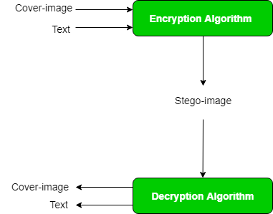
Image Steganography in Cryptography

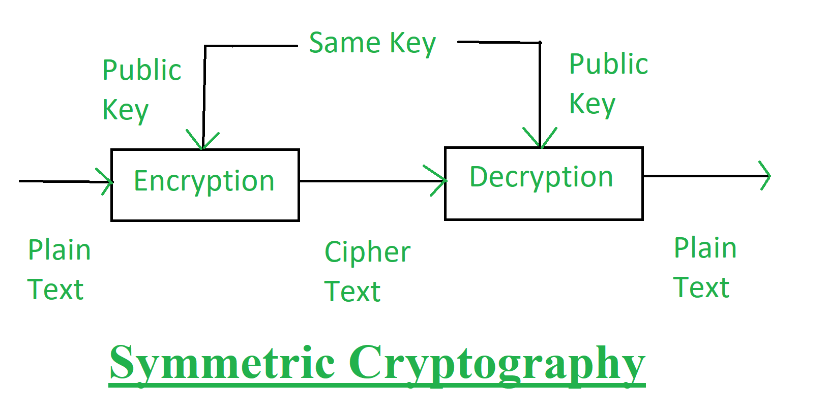
Classical Cryptography and Quantum Cryptography

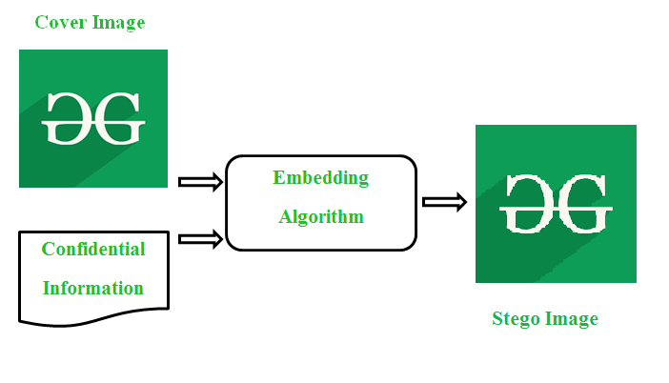
Early Evidence of Steganography


Performance metrics for image steganography

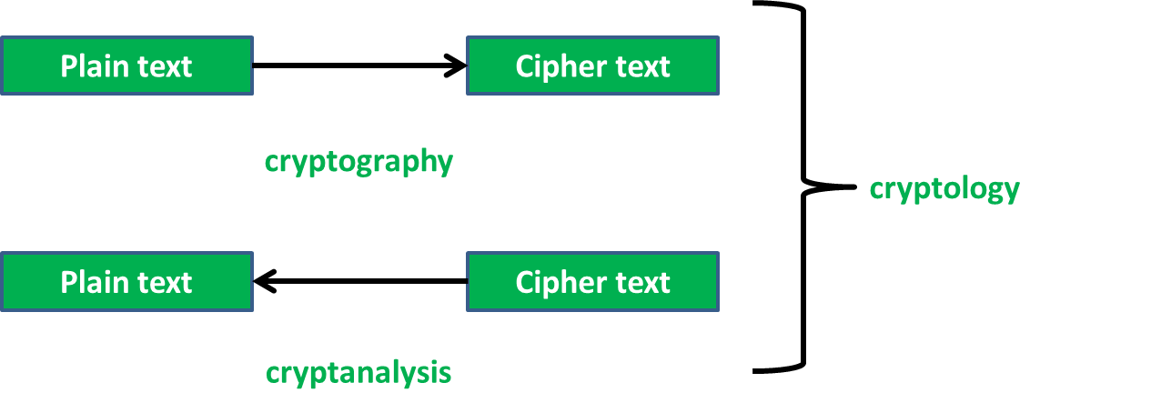
Difference between Cryptography and Cryptology

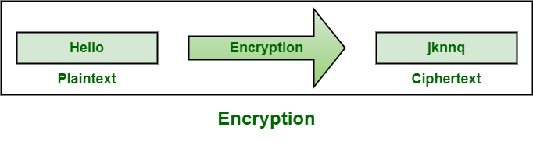
Difference between Encryption and Cryptography


Difference between Cryptography and Cyber Security


Differences between Classical and Quantum Cryptography


Cryptography and its Ty

Difference Between Symmetric and Asymmetric Key Encryption

G
gluttony777

• Read
• Discuss
• Courses
• Practice

Symmetric Key Encryption: Encryption is a process to change the form of any message in order to protect it from reading by anyone. In Symmetric-key encryption the message is encrypted by using a key and the same key is used to decrypt the message which makes it easy to use but less secure. It also requires a safe method to transfer the key from one party to another.
Asymmetric Key Encryption: Asymmetric Key Encryption is based on public and private key encryption techniques. It uses two different key to encrypt and decrypt the message. It is more secure than the symmetric key encryption technique but is much slower.
Symmetric Key Encryption | Asymmetric Key Encryption
It only requires a single key for both encryption and decryption. | It requires two keys, a public key and a private key, one to encrypt and the other one to decrypt.
The size of cipher text is the same or smaller than the original plain text. | The size of cipher text is the same or larger than the original plain text.
The encryption process is very fast. | The encryption process is slow.
It is used when a large amount of data is required to transfer. | It is used to transfer small amounts of data.
It only provides confidentiality. | It provides confidentiality, authenticity, and non-repudiation.
The length of key used is 128 or 256 bits | The length of key used is 2048 or higher
In symmetric key encryption, resource utilization is low as compared to asymmetric key encryption. | In asymmetric key encryption, resource utilization is high.
It is efficient as it is used for handling large amount of data. | It is comparatively less efficient as it can handle a small amount of data.
Security is less as only one key is used for both encryption and decryption purpose. | It is more secure as two keys are used here- one for encryption and the other for decryption.
The Mathematical Representation is as follows-  P = D (K, E(K, P))  where K –> encryption and decryption key  P –> plain text  D –> Decryption  E(K, P) –> Encryption of plain text using K | The Mathematical Representation is as follows-  P = D(Kd, E (Ke,P))  where Ke –> encryption key  Kd –> decryption key  D –> Decryption  E(Ke, P) –> Encryption of plain text using encryption key Ke. P –> plain text
Examples: 3DES, AES, DES and RC4 | Examples: Diffie-Hellman, ECC, El Gamal, DSA and RSA

Digital Signature Algorithm (DSA) in Cryptography: How It Works & More
By Baivab Kumar Jena
Last updated on Feb 14, 2023102542


Table of Contents
What Is Asymmetric Encryption?
Why is Cryptography a Smart Solution?
What Are Digital Signatures?
Block Diagram of Digital Signature
Importance of Digital Signature
View More
The Covid-19 pandemic has given a new life to the work-from-home initiative, taking the corporate world into an untapped phase. Without a doubt, most of the users reading this have had to digitally sign some official documents over the past couple of years because of the lack of face-to-face interaction and standard distance constraints. To maintain the authenticity and integrity of such documents holding critical information, the DSA Algorithm was proposed and passed as a global standard for verifying digital signatures.
Before moving forward with the algorithm, you will get a refresher on asymmetric encryption, since it verifies digital signatures according to asymmetric cryptography architecture, also known as public-key cryptography architecture.

What Is Asymmetric Encryption?
You utilize two distinct keys in asymmetric encryption methods, one for encryption and the other for decryption. You use the public key for encryption; meanwhile, you use the private key for decryption. However, you must generate both keys from the receiver’s end.
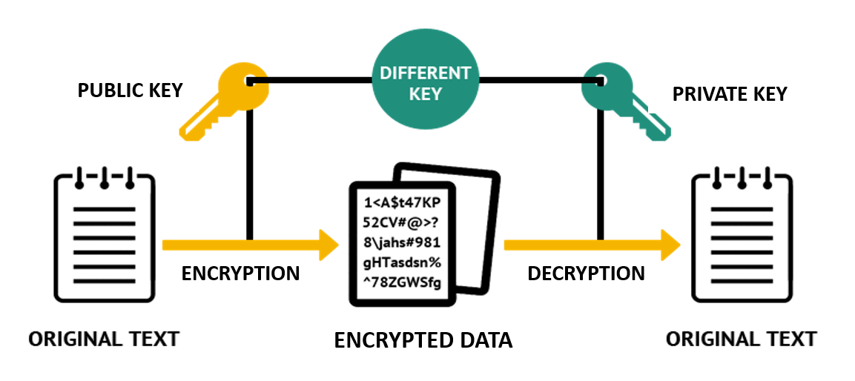
Using separate keys for encryption and decryption, as seen in the figure above, has helped eliminate key exchange, as seen in the case of symmetric encryption.
For example, if Alice needs to send a message to Bob, both the private and public keys must belong to Bob.
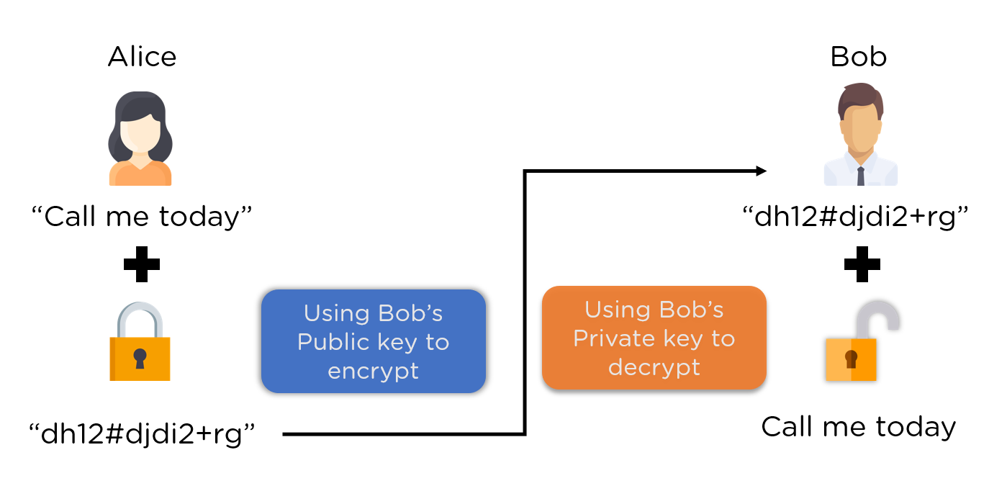
The process for the above image is as follows:
- Step 1: Alice first uses Bob’s public key to encrypt the message
- Step 2: The encrypted message reaches Bob
- Step 3: Bob decrypts the message with his secret key
This eliminates the requirement for the sender and recipient to exchange any secret keys, minimizing the window of opportunity for exploitation.
Now that you learned how asymmetric encryption happens, you will look at how the digital signature architecture is set up.

Clear CompTIA, CEH, and CISSP Certifications!
Cyber Security Expert Master's ProgramEXPLORE PROGRAM


Why is Cryptography a Smart Solution?
Cryptography involves using codes and ciphers to protect sensitive information from unauthorized access. Cryptography protects data in many applications, including banking, military communications, and secure emails.
Cryptography is a smart solution because it provides an efficient and secure way to protect sensitive data and communications. Cryptography uses advanced mathematical algorithms to encrypt data so only authorized parties can access it, and it also prevents third parties from intercepting communications or manipulating data.
It enables secure transmission over the internet, protecting data from unauthorized access and potential tampering. Cryptography also allows for data authentication, which can be used to verify the integrity of data and the sender's identity, meaning that data cannot be tampered with or changed without authorization. Finally, cryptography can authenticate users and ensure that only the intended recipient can access the data.

What Are Digital Signatures?
The objective of digital signatures is to authenticate and verify documents and data. This is necessary to avoid tampering and digital modification or forgery during the transmission of official documents.
With one exception, they work on the public key cryptography architecture. Typically, an asymmetric key system encrypts using a public key and decrypts with a private key. For digital signatures, however, the reverse is true. The signature is encrypted using the private key and decrypted with the public key. Because the keys are linked, decoding it with the public key verifies that the proper private key was used to sign the document, thereby verifying the signature's provenance.
Read more: What is Cryptography And How Does It Protect Data?
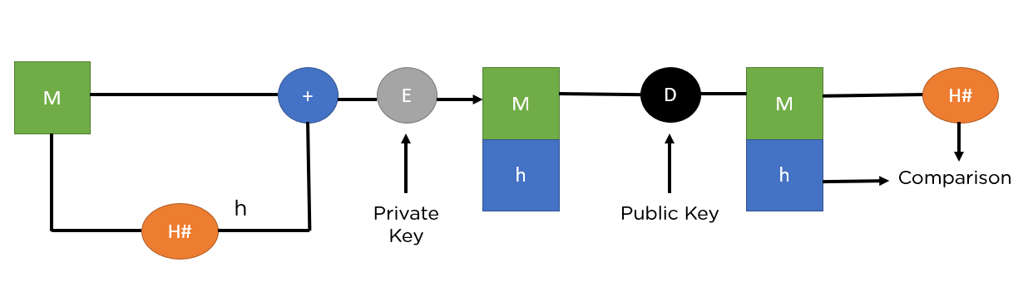
M - Plaintext
H - Hash function
h - Hash digest
‘+’ - Bundle both plaintext and digest
E - Encryption
D - Decryption
The image above shows the entire process, from the signing of the key to its verification. So, go through each step to understand the procedure thoroughly.
- Step 1: M, the original message is first passed to a hash function denoted by H# to create a digest.
- Step 2: Next, it bundles the message together with the hash digest h and encrypts it using the sender’s private key.
- Step 3: It sends the encrypted bundle to the receiver, who can decrypt it using the sender’s public key.
- Step 4: Once it decrypts the message, it is passed through the same hash function (H#), to generate a similar digest.
- Step 5: It compares the newly generated hash with the bundled hash value received along with the message. If they match, it verifies data integrity.
There are two industry-standard ways to implement the above methodology. They are:
- RSA Algorithm
- DSA Algorithm
Both the algorithms serve the same purpose, but the encryption and decryption functions differ quite a bit. So, now that you understand how it is supposed to function while verifying the signature, let’s deep dive into our focus for today, the DSA Algorithm.

Block Diagram of Digital Signature
A digital signature is a type of electronic signature based on cryptography and used to authenticate the identity of the sender of a message or the signer of a document and to ensure that the original content of the message or document is unchanged.
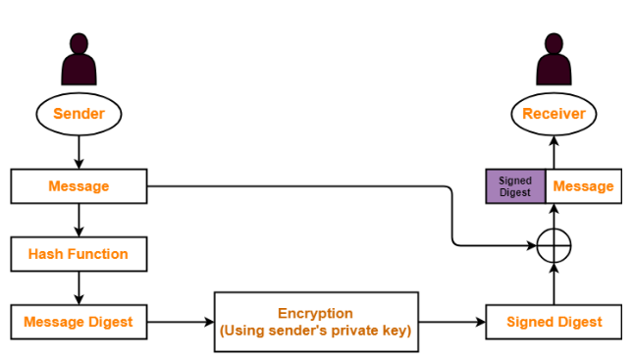
The block diagram of the digital signature process is as follows:
- Message or Document: This is the data or document that needs to be signed.
- Hashing: The document or message is converted into a fixed-length hash using a cryptographic hash function.
- Encryption: The hash is then encrypted using the sender's private key.
- Signature: The encrypted hash is the document's digital signature.
- Verification: The signature is then verified using the sender's public key to ensure the signature's validity and the document's authenticity.

Clear CompTIA, CEH, and CISSP Certifications!
Cyber Security Expert Master's ProgramEXPLORE PROGRAM


Explanation of the Block Diagram
The digital signature block diagram outlines the process of creating and verifying digital signatures.
- The process begins with a message being sent from one party to another. This message is then run through a cryptographic hashing algorithm, which produces a hash of the message.
- Then, the hash is encrypted using the sender's private key. The encrypted hash is then attached to the original message, forming the digital signature.
- After that, the recipient verifies the digital signature by decrypting the hash with the sender's public key and then comparing it to a new hash generated from the original message. This decrypting process assures that the message has not been altered in transit and can be trusted as coming from the sender. Once again, the digital signature proves that the data is from a trusted source and has not been changed.

Importance of Digital Signature
The importance of digital signatures is not negligible in this digital world, and there are some,
- Ensures Authenticity: Digital signatures ensure the authenticity of a message or transaction by proving that the message or signature was created using the private key associated with the digital signature.
- Offers Non-repudiation: A digital signature provides an entire record that a specific individual signed the document or transaction at a particular time. This feature prevents the individual from denying that they signed it.
- Provides Security: Digital signatures use encryption algorithms to protect the data from unauthorized access and tampering. The cryptographic techniques used by digital signatures also protect the data from being changed or manipulated during transmission.
- Improves Efficiency: Digital signatures can reduce the time and money spent on paperwork, printing, scanning, and mailing documents.
- Enhances Compliance: Digital signatures help organizations to meet regulatory and legal compliance requirements by providing an audit trail of signed documents.

Role of Digital Signatures
- Digital signatures are used for authentication or verification. They are used to verify the authenticity and integrity of a digital document or message.
- The prominent role of a digital signature is to ensure the integrity and authenticity of a digital document or message. A digital signature is essentially a type of electronic signature which provides non-repudiation and authentication between two parties. It serves as proof that the two parties have agreed to specific terms and conditions and have mutually verified the contents of a document or message.
- Digital signatures can also protect confidential information, ensuring that only authorized persons can access the data.
- Furthermore, digital signatures can also be used to track a digital transaction's source and ensure that it has not been modified.

Encryption With Digital Signature
Encryption is transforming information (referred to as plaintext) using an algorithm (called cipher) to make it unreadable to anyone except those possessing special knowledge, usually referred to as a key. The process's result is encrypted information. In cryptography, this encrypted information is referred to as ciphertext.

